Diseño Esquemático

Flip-Flop JK

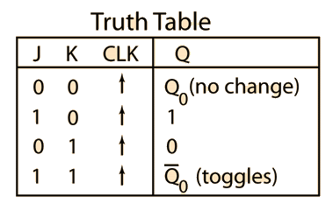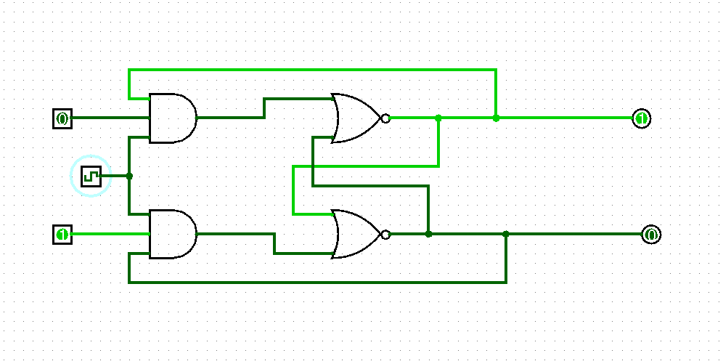

Contador con flip flops

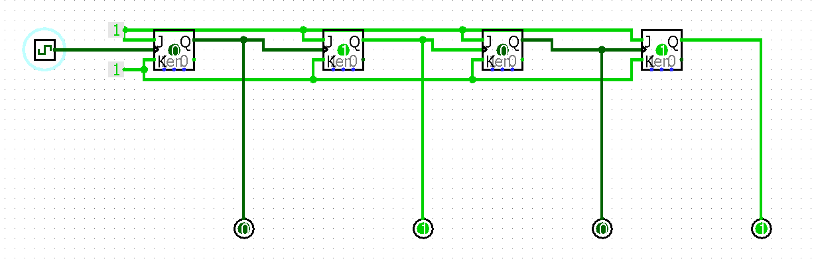

Contador de década, se agrega condición para que se recete cuando llegue a 10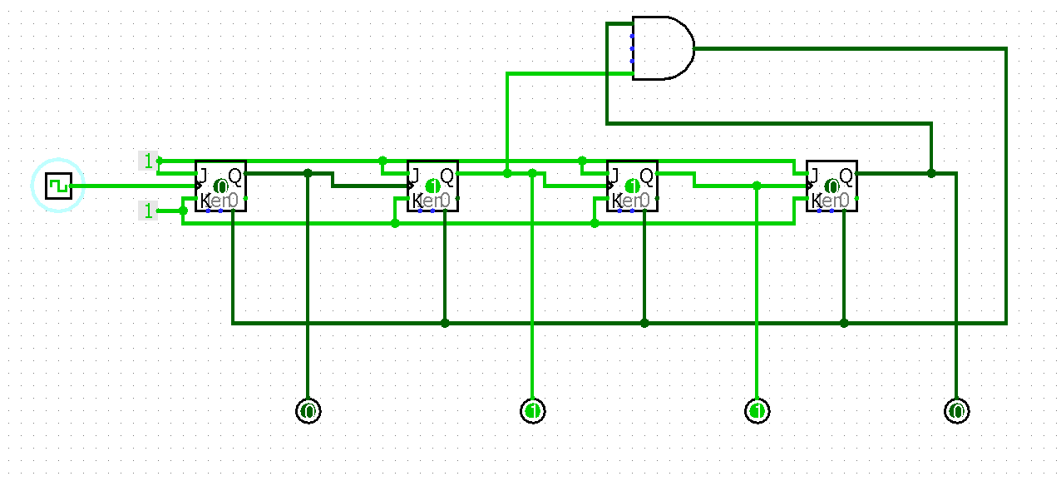

Contador a 99

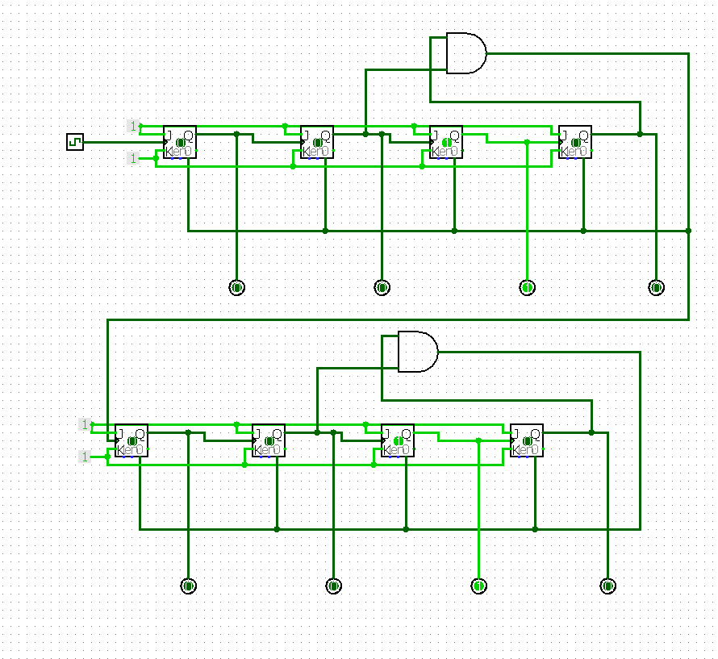

Diseño Contador decimal ascendente y descendente

|  |  |  |  |  |  |  |  |  |  |  |  |  |  |  |  |  |  |  |  |
| --- | --- | --- | --- | --- | --- | --- | --- | --- | --- | --- | --- | --- | --- | --- | --- | --- | --- | --- | --- |
|  | X | Q3 | Q2 | Q1 | Q0 |  | Q3 | Q2 | Q1 | Q0 |  | J3 | K3 | J2 | K2 | J1 | K1 | J0 | K0 |
| 0 | 0 | 0 | 0 | 0 | 0 |  | 0 | 0 | 0 | 1 |  | 0 | X | 0 | X | 0 | X | 1 | X |
| 1 | 0 | 0 | 0 | 0 | 1 |  | 0 | 0 | 1 | 0 |  | 0 | X | 0 | X | 1 | X | X | 1 |
| 2 | 0 | 0 | 0 | 1 | 0 |  | 0 | 0 | 1 | 1 |  | 0 | X | 0 | X | X | 0 | 1 | X |
| 3 | 0 | 0 | 0 | 1 | 1 |  | 0 | 1 | 0 | 0 |  | 0 | X | 1 | X | X | 1 | X | 1 |
| 4 | 0 | 0 | 1 | 0 | 0 |  | 0 | 1 | 0 | 1 |  | 0 | X | X | 0 | 0 | X | 1 | X |
| 5 | 0 | 0 | 1 | 0 | 1 |  | 0 | 1 | 1 | 0 |  | 0 | X | X | 0 | 1 | X | X | 1 |
| 6 | 0 | 0 | 1 | 1 | 0 |  | 0 | 1 | 1 | 1 |  | 0 | X | X | 0 | X | 0 | 1 | X |
| 7 | 0 | 0 | 1 | 1 | 1 |  | 1 | 0 | 0 | 0 |  | 1 | X | X | 1 | X | 1 | X | 1 |
| 8 | 0 | 1 | 0 | 0 | 0 |  | 1 | 0 | 0 | 1 |  | X | 0 | 0 | X | 0 | X | 1 | X |
| 9 | 0 | 1 | 0 | 0 | 1 |  | 0 | 0 | 0 | 0 |  | X | 1 | 0 | X | 0 | X | X | 1 |

|  |  |  |  |  |  |  |  |  |  |  |  |  |  |  |  |  |  |  |  |
| --- | --- | --- | --- | --- | --- | --- | --- | --- | --- | --- | --- | --- | --- | --- | --- | --- | --- | --- | --- |
| 16 | 1 | 0 | 0 | 0 | 0 |  | 1 | 0 | 0 | 1 |  | 1 | X | 0 | X | 0 | X | 1 | X |
| 17 | 1 | 0 | 0 | 0 | 1 |  | 0 | 0 | 0 | 0 |  | 0 | X | 0 | X | 0 | X | X | 1 |
| 18 | 1 | 0 | 0 | 1 | 0 |  | 0 | 0 | 0 | 1 |  | 0 | X | 0 | X | X | 1 | 1 | X |
| 19 | 1 | 0 | 0 | 1 | 1 |  | 0 | 0 | 1 | 0 |  | 0 | X | 0 | X | X | 0 | X | 1 |
| 20 | 1 | 0 | 1 | 0 | 0 |  | 0 | 0 | 1 | 1 |  | 0 | X | X | 1 | 1 | X | 1 | X |
| 21 | 1 | 0 | 1 | 0 | 1 |  | 0 | 1 | 0 | 0 |  | 0 | X | X | 0 | 0 | X | X | 1 |
| 22 | 1 | 0 | 1 | 1 | 0 |  | 0 | 1 | 0 | 1 |  | 0 | X | X | 0 | X | 1 | 1 | X |
| 23 | 1 | 0 | 1 | 1 | 1 |  | 0 | 1 | 1 | 0 |  | 0 | X | X | 0 | X | 0 | X | 1 |
| 24 | 1 | 1 | 0 | 0 | 0 |  | 0 | 1 | 1 | 1 |  | X | 1 | 1 | X | 1 | X | 1 | X |
| 25 | 1 | 1 | 0 | 0 | 1 |  | 1 | 0 | 0 | 0 |  | X | 0 | 0 | X | 0 | X | X | 1 |

J3= X’Q1Q0Q2 + XQ2’Q1’Q0’

K3= X’Q0 + XQ0’

J2= X’Q1Q0 + XQ3Q0’

K2= X’Q1Q0 + XQ1’Q0’

J1=X’Q3’Q0 + XQ2Q0’ +XQ3Q0’

K1=X’Q0 + XQ0’

J0= 1

K0= 1

ENABLE DE DECIMAS

en <= (Q0 and Q1N AND Q2N AND Q3 and XN) OR (Q0N AND Q1N AND Q2N AND Q3N AND X);

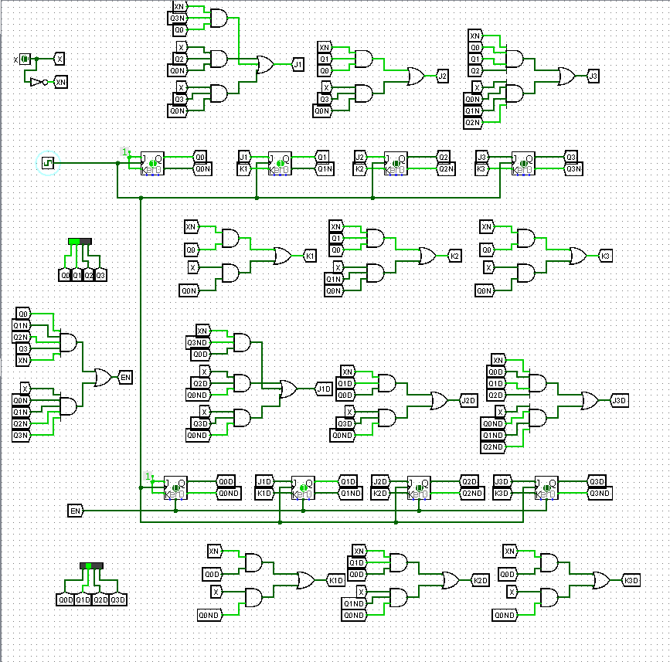Contador Final Ascendente y Descendente